**Guide for Keypad 4x4**

1. **Login TinkerCAD**



1. **Create New Circuit**

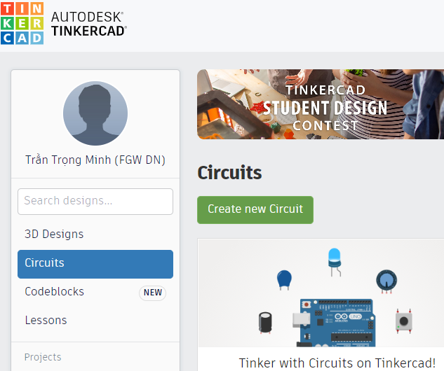

1. **Select devices**

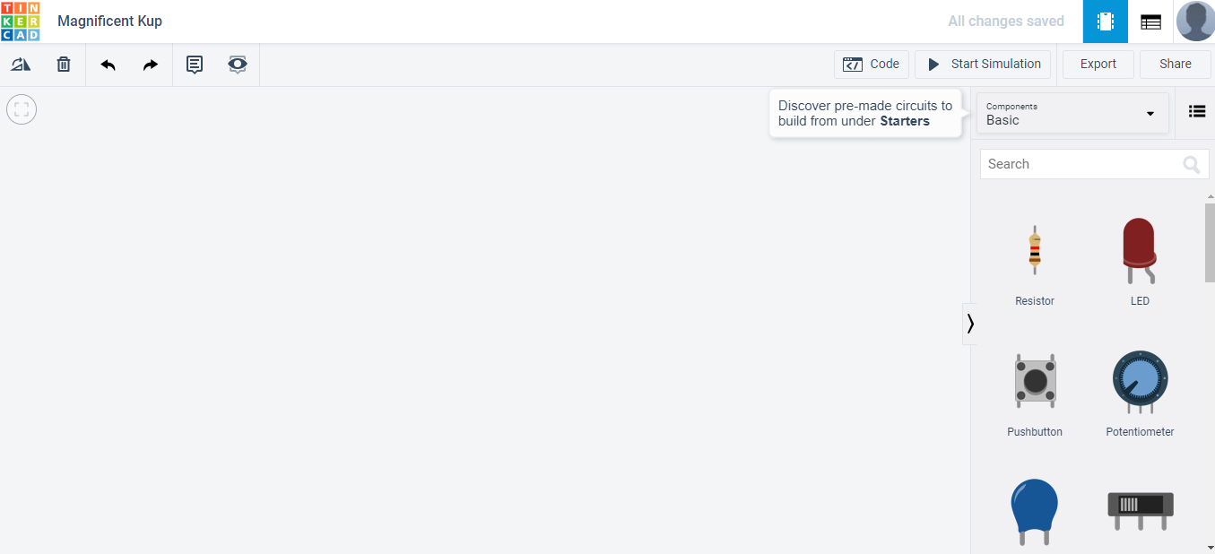

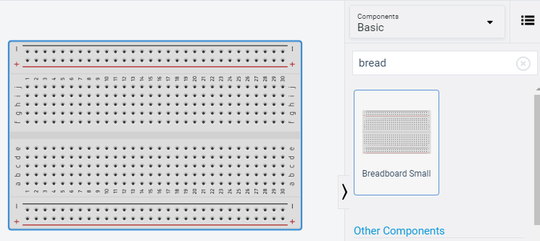

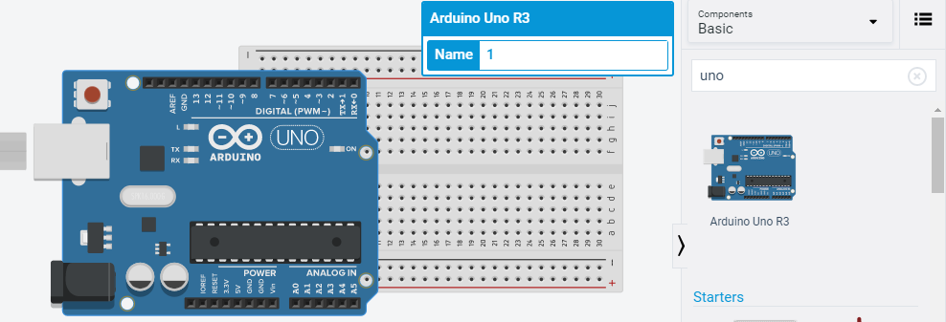

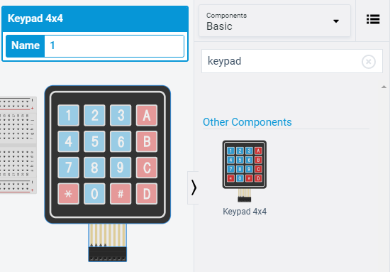

1. **Keypad 4x4 and the circuit**

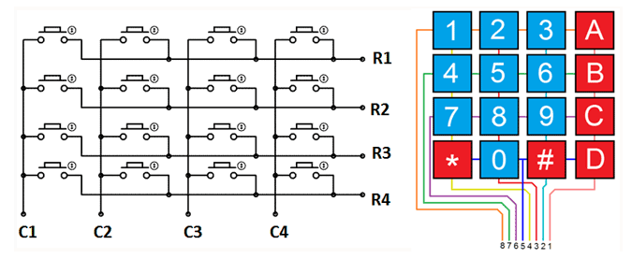

|  |  |  |
| --- | --- | --- |
| Arduino | Keypad | Keypad Pin |
| 5 | R1 | 8 |
| 6 | R2 | 7 |
| 7 | R3 | 6 |
| 8 | R4 | 5 |
| 9 | C1 | 4 |
| 10 | C2 | 3 |
| 11 | C3 | 2 |
| 12 | C4 | 1 |

1. **Connected circuit**

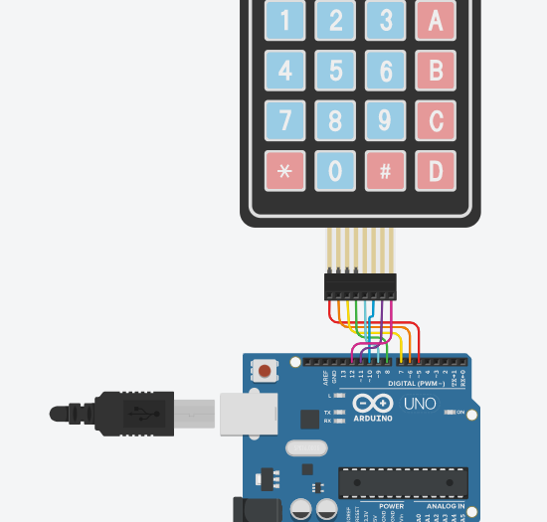

1. **SKETCH**:

#include "Keypad.h";

/*

Lib: https://github.com/Chris--A/Keypad/archive/master.zip

*/

// Define some constants and variables

const byte rows = 4;

const byte columns = 4;

int holdDelay = 700;

int n =3;

int state = 0;

char key = 0;

//Define characters matrix

char keys[rows][columns] =

{

{'1', '2', '3', 'A'},

{'4', '5', '6', 'B'},

{'7', '8', '9', 'C'},

{'*', '0', '#', 'D'},

};

//Define pins for every row of keypad

byte rowPins[rows] = {5, 6, 7, 8};

//Define pins for every column of keypad

byte columnPins[columns] = {9, 10, 11, 12};

// Create an instance for our keypad

Keypad keypad = Keypad(makeKeymap(keys), rowPins, columnPins, rows, columns);

void setup()

{

//Setting serial monitor with baudrate 9600

Serial.begin(9600);

}

void loop()

{

char temp = keypad.getKey();

if ((int)keypad.getState() == PRESSED)

{

if (temp != 0) {key = temp;}

}

if ((int)keypad.getState() == HOLD)

{

state++;

state = constrain(state, 1, n);

delay(holdDelay);

}

if ((int)keypad.getState() == RELEASED)

{

key += state;

state = 0;

Serial.println(key);

}

delay(100);

}

1. **Upload your sketch and test**